A Metric of Common Goods Dynamics

Mathias Nebel & Ignacio Arbesu-Verduzco

  - SUMMARY
This article proposes a common good approach to development. In the first part, we formalize what we understand by such an approach and propose a matrix of common good dynamics. The second part develops a metric to capture at the level of municipalities the present dynamic of the nexus of common goods. The third part revises how we can appraise and understand the data we get from the metric. The last part is dedicated to the value that the added information from the given approach may provide to development practitionners.
Key words: development, common good approach, social dynamics, Mexico.
JEL Classification: O10; Z13; Y80

Introduction
  - Aim of the Research Project
The research question addressed by this paper is quite straightforward: How can we assess and measure the quality of a given ‘system of common goods’ at the local level? This first query obviously involves several others: What do we understand by ‘common goods’? Is it meaningful to adopt a common good perspective on development? Should we really add to the ever-growing list of indicators and metrics, a new one? What are we really looking for in a common good indicator and what advantages can we expect for the local population from such a perspective?
First, a word about the common good. For centuries, the concept served as the main framework to understand social processes and shape policies (Hibst, 1991; Lecuppre-Desjardins & Van Bruaene, 2010). As an architectonic concept (Kempshall, 1998), the common good articulated the practice of government, law, taxes, guilds and free cities (Rigaudière, 2010; Sassier 2010). The concept was not deemed theoretical but rather practical. It was a way to understand and govern the many ‘commons’ around which societies gathered. It was the emergence of the modern state coupled with the shift toward social contract theories that slowly eschewed the concept to the sideline of modern thought (Zamagni & Bruni, 2007). So much so that today the very concept of the common good appears ambiguous to most people; definitively not something that would help us towards a more efficient practice of development (Hollenbach, 2002, 3-31). It is this vision that the article is challenging. It focuses on the practical relevance of a ‘common good perspective on development issues’ in order to see if it can give us an edge in policy making and governance at group and community level.
To do so, we first elaborated a matrix then a metric of common good dynamics that we then applied to several municipalities. This article presents the matrix (first point) as well as the metric (second point) and introduces the way we read our results (third point). It then shows, on the ground of the pilot probe in Ocotepec, what kind of information can be gathered from such an approach (fourth point). Other articles in this special issue will then revise the statistical validity of the model and present the results of two further applications of the metric.
  - History of the Project
Our metric of common good dynamics is the result of a research project that has spanned for over three years gathered by a group of local and international researchers. It was headed by the Instituto Promotor del Bien Común (IPBC) located at the Universidad Popular Autónoma del Estado de Puebla (UPAEP). The goal of the project was to devolve operationality to a notion usually confined to rhetoric and wishful thinking. The first challenge was obviously to come up with a clear notion of the common good that might then leads us towards an understanding of the key elements needed to trigger common good dynamics. Indeed, more than focussing on outputs and results, we thought that we should focus on social processes, that is, on the way different common goods build up in a society to form a network of common goods. To understand what drives this dynamic equilibrium quickly became our goal.
Give this, three research seminars were organised between 2017 and 2018 in Puebla (UPAEP), Barcelona (IQS) and South Bend (ND). Each gathered typically 25 invited scholars to work on the design of a matrix of common good dynamics. A discussion paper prepared by the IPBC, would focus the debate during the two day seminars and lead to a revised proposal for the next one. In February 2019, a first version of a matrix and a metric of common good dynamics was presented at an international conference organised by UPAEP. In the following months, the IPBC’s research team came up with a questionnaire (metric), which was analyzed in regular meetings of the local committee, tested through cognitive interviewing and finally tested through two pilot probes applied in May and June 2019 in Atlixco and Ocotepec. The questionnaire was then duly revised and successively applied in two other municipalities between July and December 2019 (Atlixco and San Andres Cholula). The results were analyzed on regular meetings of the local research committee and presented at a fourth research seminar in March 2020 in Puebla.
The first statistically formal application took place in San Andres Cholula, a peri-urban municipality near the city of Puebla. It was previously a mostly indigenous village but was conquered by the urban sprawl since the turn of the century. Its population has grown to reach a staggering 160,000 people, mostly newcomers from other parts of the country. Its economy is diversified, comprising industry and service as well as agriculture. 40% of the population is classified as poor, with only 3% in extreme poverty, which is well below the national mean of Mexico (CONEVAL 2015). Indeed, by income, it is one of the wealthiest municipalities in Mexico. Inequalities are correspondingly higher than in other parts of the state of Puebla. The structure of the municipality is complex, with the old village now embroiled with gigantic gated communities, shopping malls, industries and – there’s still – open land dedicated to agriculture. We reached an agreement with the municipality to conduct the survey using a professional polling agency, with the IPBC research team then analysing the data. 650 questionnaires were applied during November and December 2019. We selected a sample reflecting the age, education, gender and location of the population. The questionnaire itself provided indicators for socio-economic status and indigenous belonging.
A second application took place in Atlixco, a rural town about 40 kilometres from the city of Puebla with a total population of 136,000 people. Laying lower than the state capital (1900m ASL) and with plenty of water, it is mainly dedicated to intensive agriculture and horticulture. Many people however work in the city of Puebla and commute every day. The municipality is generally poor (60%), with 10 % still living in extreme poverty. Income is a problem with over 67% living under the CONEVAL´s ‘well-being line’. The structure of the municipality is made up by the town of Atlixco and 12 small villages dispersed around it. We also reached an agreement with the municipality to conduct the survey through the ‘Tecnologico de Atlixco,’ a small technological College and a professional polling agency. We applied 550 questionnaires within a sample, reflecting the age, education, gender and location of the population. The questionnaire itself provided indicators for socio-economic status and indigenous belonging.

A Matrix and Metrics of Common Good Dynamics
  - A Common Good Approach to Development: Aims of the Metric
Most development indicators rely on individual data and measure development achievements through individual goods, entitlements or functionings. However, the systemic dimension of development, while recognized, is usually not resolved, like in the present SDGs. Societies are complex and interrelated social systems and development can only be achieved as a whole and not by bits and parcels here and there. How the social environment does shape these individual goods, entitlement or functionings, is a question eschewed by most development indicators or replaced by clever mathematics. Growing literature argues therefore that we also need to include group or community data in order to grasp and measure ‘collective achievements’ of goods or services that are essentially ‘shared’ or ‘common’. Different approaches to development have advanced in this direction: social capital (Putnam, 2000), public goods (Kaul, Grunberg & Stern, 1999), commons (Ostrom, 1990), social rights (Ulrike, 2013), collective capabilities (Ibrahim, 2016), etc.
A common good approach to development focuses precisely on groups or communities, concentrating on the processes through which they value, create and govern a specific set of social goods. Commons refer and are embedded in commoning practice (De Angelis & Harvie 2013). These goods are understood as irreducible social goods, i.e. goods ‘build on’ and ‘embedded in’ relationships. As Taylor (1995) argues, goods that are immanent to the cooperation of people in a community; immanent to collective organization that allows the achievement of a social good; and immanent to the shared understanding of their value. While a common good approach recognizes the need and value of individual based indicators, it contends that they may fully explain the social processes involved in development. A common good perspective adopts the view that development is not first and foremost a matter of individuals but of groups, communities or nations. It seems then that describing and measuring the processes through which a community achieves a network of common goods may be relevant to understand development topics.
Now there is no shortage of metrics that try to measure development as well-being or happines (Human Development Index, World Happiness Report, , . Most summarize development through a list of items for which they provide indicators and metrics. It may be basic needs, human security, lists of capabilities, human rights or either selected features of human flourishing. But most of them focus on either preconditions for well-being development or a selected set of achievements or functionings. Our approach is different. We focus on commons and the processes by which these build up in society to create a nexus-of-commons, that is a system of common goods. By concentrating on these dynamics, our aim changes. We will be looking for the drivers of this dynamic and for a normative horizon (Ricoeur, 2001)– a North Pole – by which we may judge the quality of a nexus’ dynamic. We will argue, using the literature on commons (Ostrom, 1990, 2009; Van Laerhoven & Berge, 2011; De Angelis & Harvie, 2013; Euler, 2018), that drivers must include collective freedom, justice, governance and sustainability. We will then argue that humanity rather than justice may be recognised as the normative horizon of common good dynamics (Rawls, 1971; Nebel, 2018a).
  - Overview of the Matrix
A society can be described through the set of common goods it values, produces, distribute and sustains over time. In turn a specific common good may be defined as an interaction of people, gathered around its consecution (Nebel, 2018a). This dynamic understanding of common goods entails the complex process by which a group values the common, organizes to efficiently produce it, governs it and distributes the common benefit it creates.
But no specific common good exists in isolation, just for itself. Each one is part of a wider system of common goods we will refer to, as the nexus of common goods. Each common good within the nexus is related to others, often imperfectly, to build a complex and dynamic equilibrium (Nebel, 2018b). This equilibrium implies that the different conflicts and tradeoffs between the existing common goods have reached a certain arrangement along specific hierarchies that structure and identify the nexus as unique. Each nexus is therefore different, each culture and nation generates a specific arrangement on the basis of its own history and worldview. Neither is this equilibrium definitive. It changes, by definition, as the historical relevance of some commons fade, new arise and the population evolves in the values recognized by the hierarchy of common goods. One good example is the role of faith and religion in Western Europe that has swiftly changed during the second part of the XX Century to become far less relevant to the hierarchy of common goods in these countries (European Values Study, 2015).
The changes in this equilibrium are not autopoietic (Nebel, 2018b). Nexus of common good do not grow erratically in the dark, like mushrooms or transform mechanically along some preexisting tracks. The nexus is a human construct. While the governance of the nexus is necessarily polycentric, a certain amount of governance of the equilibrium exists and is indeed required (Ostrom, 2009). Political governance can be seen as the steering wheel of the nexus, overseeing not only the present coherence and quality of the equilibrium, but also its overall direction. Both tasks – increasing its present coherence and quality, and expanding it towards a general direction – requires normative drivers of change to be identified- on which to gauge the quality of this governance.
On the ground of a theoretical understanding of common good dynamics on one hand, (Nebel 2018a) and a vast corpus of empirical evidence on the other, we propose the following matrix of common good dynamics. Five key normative drivers are identified: collective agency freedom as the main engine of common good dynamics; humanity is seen as the normative horizon toward which common good dynamics should aim at; while governance, justice and stability are seen as social functions structuring the nexus and driving it toward a deeper and broader human coherence. Together, these five normative drivers are required to generate social processes that work toward a more human coexistence in a nexus.
Figure 1. The matrix of common good dynamics
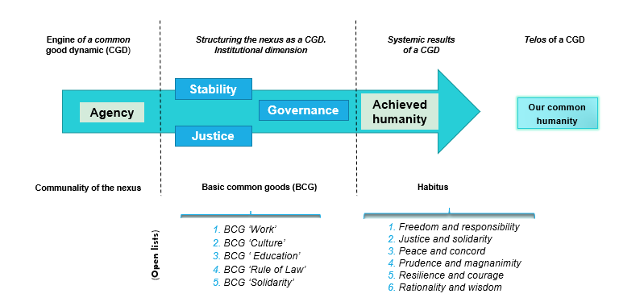
  - Description of the Key Drivers of Common Good Dynamics
The normative role of each dimension is specific. ‘Colective agency freedom’ may be understood as the systemic precondition of common good dynamics, i.e. the efficient causality of the nexus. ‘Justice, stability and governance describe key systemic social functions organizing the dynamic and required to lead the nexus towards the universal common good; social functions, in other terms, that are normatively bound to the achievement of the common good (formal causality). Finally, humanity refers to the systemic achievement of common good dynamics (end causality).
‘Collective agency freedom’ refers to the overall capability of a nexus population to engage with others and act together freely, aiding with the consecution of social goods. It is the collective capability to act together and give a solution to common problems. This capability is embedded in various formal and informal institutions structuring the nexus.
Three core systemic social functions are seen as structuring the nexus: (a) ‘Governance’ describes the capability to lead the nexus towards an ever broader and deeper human integration. The nexus’ governance is polycentric and abide to an organic subsidiarity; (b) ‘Justice’ describes how people take part and have part in the social goods produced by the nexus, i.e. the fair generation of the different social goods making up the nexus and the just distribution of the common benefits among the people; (c) ‘Stability’ defines the social institutions preserving and enriching the achieved humanity of the nexus and ensuring its future. These are the institutions that preserve, transmit and reinvent the nexus’ humanity providing it with resilience and sustainability. Each of these three key systemic social functions are correlated, subsequently checking and correcting the two others. Together they structure the nexus and bring about a common good dynamic.
Finally, ‘Humanity’ - the systemic achievement of a common good dynamic - denotes the human quality of our coexistence in the nexus; how we relate and act together as human beings in that particular society. More precisely, we characterize ‘humanity’ as the achievement of a set of basic common goods and core habitus.
  - Two Thresholds to Measure Humanity: Basic Common Goods and Standard Expectation of Behavior
As we can’t take into account the full complexity of common goods existing in a society, we choose to focus on a set of basic common goods that are required to access our own humanity. Relational goods, in other terms, linked to our common basic needs and conditioning the access to our humanity, like culture, education, work, laws and social norms. These basic common goods are systemically important, meaning that without them the social fabric would hardly exist at all. Their existence and distribution among the population may thus be considered as a minimal threshold of humanity. Whenever they fail to exist or be accessible, the nexus falls below a minimal standard of humanity and will not – whatever its wealth or efficiency – be leading towards a more human coexistence.
To draw such minimal threshold of humanity we selected the following set of basic common goods for our matrix: culture, education, solidarity, work and rule of law. This open list does not claim to be comprehensive and is open to further discussions, but fits the need to create a metric adapted to measure CGD in municipalities. The very existence of these basic common goods at local level can be taken as a fair proxy for a minimal threshold of humanity. Their existence, coherent integration and distribution in a population tell us something important about its basic human quality.
As to specific common goods, their existence and distribution will be assessed at the level of the three key drivers structuring the nexus and informing the core nexus: justice, governance and stability. In other words, we will be considering how these basic common goods are governed, how they are distributed in the population and if their provision is stable or not.
But a common good approach to development does not settle only for a minimal threshold of humanity, we are concerned with the overall outcome of the social system in terms of humanity, thus proposing to measure the core habitus generated by the nexus. Indeed, each nexus actualizes some values linked to its main institutions and overall architecture; values that can be seen as its systemic outcome. Now these are not abstract values, but concrete ones, embedded in the common practices building up the humanity of our living together. According to Bourdieu (1990, 53, 135-142), these core habitus describe the permanent internalization of a given social order in a person – in our case the nexus – that does not prescribe any specific actions, but nonetheless orient actors to some specific set of goals. Habitus are the subjective, internalized representation of a given social order. They are not heteronomous norms to the subject, but important features of its own autonomy. Habitus are the way through which a social system normalizes and synchronises individual behaviours; how it produces similar forms of behaviours without pressure on or restriction to individual freedom (Giddens, 1986, 25-27). Social habitus are thus objectivized as ‘standard expectation of behaviour’ (Bourdieu, 1990, 135-142), i.e. the behaviours that others expect me to abide by, like paying after eating in a restaurant, not jumping on a table in a classroom or not commiting murder to solve a conflict with my neighbour.
Now, for the matrix, we are not interested in any social habitus, but only in a normative set of social practice against which to compare the habitus created by a specific nexus. We propose the following list to account for the values and social practices around which most, if not all, polities have been organized. They reflect a widely shared wisdom of what being human together means, as far as behaviours are concerned.
- The habitus of freedom and responsibility framing the capability to act as autonomous persons and take responsibility for our own decisions and actions.
- The habitus of justice and solidarity framing the capability to respect the dignity and freedom of others and help them in time of need or distress.
- The habitus of peace and concord framing the capability to trust others not to use violence to resolve conflicts and seek cooperation and consensus as the way to govern our polity.
- The habitus of prudence and magnanimity framing the capability to seek the truth and foresee the consequences of our actions.
- The habitus of resilience and courage framing the capability to resist the tribulations of time and face the difficulties with resolution and determination.
- The habitus of practical reasoning and wisdom framing the capability to engage reality through reason and seek to inhabit this reality as human beings.
Together the two sets of information – basic common goods and standard expectation of behaviour – will inform us of the humanity achieved by a given nexus.

  - A Relational Approach: Correlation of the Five Dimensions
As Zamagni points out, the logic of the common good is not that of a sum where each variable adds up to the total but is altogether independent (Zamagni, 2018). This aggregation logic allows for one variable to be zero without affecting the score of the other variable. The logic of the common good is rather that of a multiplication, where the score of each variable directly affects the total product. If one of these is null, then whatever the other variable, the product is zero.
Thus, the five normative drivers of common good dynamics are not to be considered independent elements. They are relational, by which we mean that the normativity of each one relates to that of all the others. In other words, ‘agency’ alone is not sufficient in itself. It must be concomitant with the requirements of justice, good governance and stability to help produce common good dynamics and hence a truly human coexistence in the nexus. Exactly as ‘justice’ won’t generate common good dynamics if it does not foster, at the same time, agency, stability and governance.
An analogy may help us understand this important point. Let’s imagine that a nexus is like a big ship. Then the rear engine would be collective agency freedom, while several smaller mobile engines situated at the front (governance) and the two sides (stability and justice) help steer the ship. All engines must point toward the same direction (humanity) in order for the ship to advance along a straight line. If one of the engines doesn’t function well or is not coordinated with the others, the whole ship will slowly lose its heading. Worse still, if none of the engines work together then the ship’s movement will become chaotic, either going in circles or stalling altogether. The coherence of the engines and the ship’s direction towards more humanity is the information that the matrix provides. In other words, it informs us of the nexus’s coherence and heading.

Measuring Common Good Dynamics in Municipalities:The Metric
  - Elaboration of the Questionnaire
On the ground of our matrix, we developed a metric to measure common good dynamics at a local level, that is, the strength and direction of social processes leading to a more human coexistence. The objective was to create a metric that would identify key information, provide robust data and still be elegant and simple enough for the results to be communicated easily. The same IPBC research group that created the matrix overtook the redaction of a questionnaire. A first draft was created between October 2018 and February 2019, being discussed point by point at almost weekly meetings over the same period. This first version got tested by students themselves, their parents and extended family to verify the pertinence and the overall coherence of the questions. We did also run cognitive interviewing to verify the socio-cultural understanding of each question. The results were analyzed by the research team and a new version of the questionnaire was issued. A fully-fledged pilot probe was then applied between June and July 2019 in Ocotepec, a small rural municipality in the state of Puebla. This first probe gave us a first idea of the statistical validity of the questionnaire and helped identify redundant and non-pertinent questions and led to the final questionnaire applied in San Andres Cholula and Atlixco, two other municipalities, at the end of 2019 and early 2020.
  - Structure of the Common Good Dynamic’s Instrument (The Questionnaire)
The instrument is made up of 71 questions, organized in six sections. The first section captures the socio-economic status of each respondent through a set of standardized questions proposed by the Mexican Statistical Institute (INEGI). Then the following five sections capture information for each of the five normative drivers of common good dynamics (collective agency freedom; governance, stability, justice and humanity).
The subset of questions dedicated to ‘collective agency freedom’ captures the different stages of the process by which collective agency emerges, gets organized and becomes effective. Each question settles around a specific part of this process by which people value, organize and use agency freedom in their locality. These questions tell us how much collective agency freedom exists in the nexus. More specifically, how much collective agency freedom is compatible with the actual structure of the nexus. Several other questions then investigate the relationship between collective agency freedom and the other key drivers of common good dynamics, namely justice, governance and stability (normative relationality). How is ‘collective agency freedom’ distributed, accessed (question on power) and governed? (question on participation and co-governance). Is ‘collective agency freedom’ stable or not over time? (question on sustainability). These questions indicate whether collective agency freedom builds up and contributes to a common good dynamic or not. The existence of collective agency freedom may be high in a nexus but not well distributed or unstable. In that case it may not add to the dynamic or even disturb it.
As seen before, ‘governance’, ‘justice’ and ‘stability’ are the key drivers structuring the nexus and gearing it towards an ever-growing human coexistence. The questions, relative to each of these three dimensions, follow the same pattern. A first set of questions inform about the existence, stability, distribution and provision of the five basic common goods: ‘Culture’, ‘Education’, ‘Work’, ‘Solidarity’ and ‘Rule of Law’. A second set of questions then captures how this specific driver relates to the others. ‘Governance’ questions will thus first identify if the local authority provides and governs the five basic common goods. The second set of ‘governance’ questions refer to the way local authority furthers justice, agency freedom and stability. ‘Justice’ questions capture first the distribution and access to the five basic common goods (which are meant, as basic common good, to be universally distributed and accessible), while a second set of questions investigate if governance, stability and agency freedom are well distributed and accessible in the nexus. Finally, ‘stability’ questions capture first the sustainability of the five basic common goods and thereafter the stability of justice, governance and agency freedom in the nexus.
‘Humanity’ captures the systemic outcome of the nexus in terms of standard expectation of behavior. Here the questions inform us about the six pairs of core habitus described in the previous section. It is important to remember that they capture not individual behaviours but the ‘standard expectation of behaviours’ others expect me to abide by in my actions. The questions here solely try to identify the existence and strength of the six pairs of social habits in the population. As systemic outcome of a common good dynamic, these scores should be related to the strength and coherence of the four other key drivers.
For each question, we specify the information we are trying to capture and some quantitative data that may help contrast the answer we get. The questions are drafted in such a way that they capture the perception of an individual regarding a social phenomenon. All questions, for example, ask the interviewee about some objective feature of the locality or community, trying not to capture an individual opinion, but the way people in the locality usually perceive this reality aside from the interviewee’s own position on the matter. The metric is qualitative in nature and prone to the usual perception biases linked to that sort of approaches. The careful redaction of questions, statistical methods of verification and the use of contrast quantitative data will mitigate the difficulty without fully resolving it. The unit of reference, as said before, is the municipality. However, as this is an administrative unit, we have settled for the terms locality to refer to the ‘territory of reference’ by which people think of their local setting and community to adduce to the usual relationships shaping their lives. As the data are geo-localized, we can then reconstruct the dispersion of results and capture local difference within the same municipality.
We took great care to adapt the wording of the questions in order to be understood by each one in a municipality, whatever the social status and level of literacy. We avoided conceptual terms, using local expressions whenever necessary, we settled for local proxies to grasp complex institutional arrangements. For example, we avoided using the term ‘rule of law’ since its too abstract and settled for the ‘police’s behavior’ and the ‘behavior of the local administration’ to learn about rule of law at the local level. Another example is ‘public space’. The concept is not culturally transposable since the boundaries between private and public space are not as strong in Mexico as in Anglo-Saxon countries. We settled then for questions asking about who cares for a square or a road in their locality.

Interpretation of Results
  - Scale of the Questionnaire
We chose a Likert scale to record the respondents’ answers, with values spanning from ‘Totally Agree’ (TA), ‘Agree’ (A), ‘Neither agree nor disagree’ (NN), ‘Disagree’ (D), ‘Totally Disagree’ (TD). The limitations and difficulties of Likert scales are well accounted for regarding reduced dispersion of answers, bias towards (A) and (D) and packaging of all divergent answers under (NN). However, the same limitations also have positive elements such as: being simple, easy to understand and quick to answer, and sharp contrasts in answers revealing trends rather than a detailed picture of the phenomenon.
One aspect often overseen by Likert scales is their non linearity. While (TA), (A), (D) and (TD) are part of the same informational space, (NN) is but the shadow of the former, capturing answers that can’t fit into this (limited) space. Practically people replying (NN) can’t capture their answer in one of the four first options and by doing so express their resistance or inhability to answer the question either in a negative or a positive way. We don’t know the reasons they have for choosing (NN) but the magnitude of this answer gives forth very valuable information: that of the shadow group that may eventually take position on the axis (TA), (A), (D) and (TD). The size of this potential switching group is of crucial importance, as we will see in the next paragraph.
Another important element of Likert scales is that even between (TA), (A), (D) and (TD) the space is not really continuous. What’s the difference between a person who answers ‘Agree’ and one who replies ‘Totally agree’? Or what does it mean to answer positively (A) and what differentiates this answer from the person who answers (D)? On a Likert scale, the difference between answers captures the intensity of convictions of the respondents either in their approval or disapproval of the phenomenon captured by the questions. Accordingly, (TA) and (TD) usually refer to a strong conviction or the respondent’s first-hand experience and tend to be comparatively stable answers over time. While (A) and (D) suggest a more nuanced approval, one that accounts for a mixed appraisal of the phenomenon. All in all, a Likert scale does provide information about groups of people and their relative positions with regards to their appraisal of a given social phenomenon. This is precisely the information that we are looking for.
  - Social Change and Tipping Point Theories
To make sense of the metric’s data, we borrowed both from Bourdieu’s sociology and Granovetter’s theory of tipping points (Granovetter 1978; 1983). Social order, says Bourdieu, always conveys a certain set of convictions or beliefs held as true by a population (Bourdieu, 1977, 168). Whenever this large set of convictions and beliefs is questioned by a population, social order becomes contested and therefore unstable. In certain circumstances, it will eventually collapse, revealing the inherent fragility of social structures or institutions previously held as stable. The nature of this collapse has attracted the attention of philosophers and sociologists alike. Arendt, for example, in her studies of the genesis of Nazi Germany shows that the rupture of the Humanist spirit of the Weimar Republic did reach a tipping point with the capturing of the State by National Socialist in 1933. Suddenly the previous equilibrium was lost, law and institutions changed quickly and inhuman behaviours became the new social norm. Something similar struck Granovetter while studying the demographic changes of American suburbs in the 70’s (1978). White suburbs would ‘tolerate’ a certain level of black American population, but once a certain critical mass was reached, then a tip could be observed, with the white population quickly fleeing the suburbs to settle elsewhere. These quick changes of equilibrium in social structures are the ones we are interested in (we are looking for the dynamics of social processes).
Indeed, the questions of the metric are meant to map and inform about the strength of the five key drivers of common good dynamics. The answers - along the Likert scale - allow us to appraise the social consensus sustaining them and therefore map the strength of each key driver. We need to remember that the questions try to capture a social reality, that is, the social order prevailing in the locality. While the perception may be individual, the social structure and its related social practice are a shared reality, rather felt by individuals as ‘objective’. To make it clear, we do not inquire about the respondent’s personal opinion about the social order, but what kind of social order constrains his as well as other’s behaviors in the locality.
Therefore, the distribution of answers along the Likert scale help us understand the strength of the key drivers. The more dispersed the answers, the less prevalent is a specific aspect of social order, and conversely more undecided the norms that should rule social behaviors. We may recognize here Durkheim’s notion of anomia, which describes not so much the absence of stable social norms, but a situation of competing and antagonist norms making a social system incoherent and unpredictable. On the other hand, whenever the answers are converging they may do so in several manners: (a) Either on the negative (D & TD) or positive side of the scale (A & TA); (b) on both extremes of the scale at the same time (TD, TA), (c) or in the middle of the scale (NN). All situations described by (a) depict a relatively stable situation (either positive or negative), while the situation of (b) and (c) can be seen as unstable. This stability or instability and the typing zones between the two are at the core of our research. It is here that recent developments in Granovetter’s theory of tipping are inherent.
The study of critical mass in collective action (Marwell & Oliver, 2007) has been radically enhanced in the last decade by the possibility of running computer simulations of social behavior changes (Centola, 2018, 179-189; Speiser et alii, 2018; Widermann et alii 2020). These studies have confirmed the existence of tipping thresholds in most social structures; thresholds beyond which social practices quickly change towards a new equilibrium. Moreover, these models revealed some dominant and constant features of tipping thresholds that appear to be remarkably stable across a wide array of social phenomena.
The first of these is the relative size of the population that differs from the existing social norm and adopts a new behavior. This is by far the oldest assumption (Granovetter, 1978, 1983). Under a certain minimal threshold of adoption, no change of social practice is possible. Under it, the minority behavior is no threat to the dominant behavior and they may coexist. But once a critical mass is reached, the dominant social behavior may tip over quickly. For a long time, the whole point was the difficulty to identify the population threshold with precision (Marwell & Oliver 2007, 48-57). Empirical studies showed that size alone was not enough to predict the behavior threshold and that the specificity of each case accounted for different tipping thresholds. However, with the possibility of multiplying experiments through computer models and verifying the impact of each variable, an active minority behavior of 20% is seen as part of the constant features of tipping thresholds (Centola et alii, 2018; Widermann et alii 2020).
The second feature of tipping threshold is the strength of the minority’s conviction about its own behavior (they are not ashamed of breaking the social norm and sticking to the new behavior). The fact that they resist falling back into the dominant behavior implies that over time, the minority behavior has an advantage over the dominant practice which is more prone to change (Centola 2018, 66-78).
A third feature is represented by the size of the swing population, that is the population that may adopt a new behavior (Centola 2018, 96-108). The more a population is polarized around strong convictions and practice, the smaller the size of the population that is open to change and therefore able to tip over a dominant behavior. The size of this swing population, while not enough in itself, must be typically over 20% for a tipping threshold to exist (Centola et alii, 2018).
A final feature also emerged from Centola’s work (2018, 34-62), apparently more technical. It has to do with the role of short and intensive relationship clusters (strong ties) and their interactions with ‘wide long bridge’ relationships (weak ties). The first typically describes small and dense family networks where strong relationships and repeated contacts ensure the social reinforcement needed to adopt a new behavior (Centola, 2018, 38-41). However, the small size and relative isolation of these clusters is in itself an obstacle for the social spread of new behaviors. Bottled in a set of small clusters a new behavior may become that of an ‘urban tribe’ in a ghetto. Without ‘wide long bridges’, that is, relationships that link otherwise independent small clusters of population, most minority behaviors will fail to spread beyond a limited set of population clusters, even if the two previous condition are met (strenght of the minority’s conviction ; size of swing population, Ibid, 78-83). The importance of these ‘wide long bridges’ is that they spread the behavior to otherwise independent sets of small clusters (long bridges) but being that they are ‘wide,’ (more than two relationships per bridge) they also have the reinforcement effect needed for the behavior to be adopted.
In the case of our metric, we will retain the three first features presented here namely – size, strenght and swing - to analyse the stability of our five key drivers. We assume that the fourth feature (strong ties clusters and existence of ‘wide long bridges’) exist, as we work at local level and in a Mexican context, where rich, strong and interrelated clusters of relationships are the norm.
  - Measuring the Five Key Drivers as Positive or Negative Social Dynamics
The previous point allows us to propose an analysis of the different shapes taken by our results on the Likert scale.
- We may have L shapes (respectively inverted ˩ shapes), characterized by high TA and A (respectively high TD and D) while other answers stay below 20%. L shapes describe stable dominant social norms, either negative or positive.
- We may have M shapes with more or less bigger feet at the right or at the left. (TD+D) and (TA+A) are bigger than 25 % while the (NN) answers stay low. This points to a polarized situation, with one norm still prevailing a strong opposition but not enough switch population to tip over the prevailing norm. M shapes describe fragilized social norms, either negative or positive.
- We finally may find different forms of Δ shapes corresponding to the tipping zone or tipping threshold with bigger levels of (NN) than (D) or (A). Δ shapes describe different levels of anomia where swift change of social norms are to be expected.
This first crude analysis of shapes led us to a more detailed description of the solution space of our metric represented in appendix one from the perspective of tipping point theories as highlighted by the works of Centola. While the statistical aspect of this solution space is discussed elsewhere in this issue, (Cf. Avila-Valdez & Castro-Manzano) we need to make at least a couple of remarks.
First, the solution tree allows us to transform our first-hand results into a description of the social dynamics of the norm they try to capture, along the lines of Centola’s tipping point theory. Second, note that the complex description tree leads to subsets and consequently 30 submarks, where 1.1, 2.1, 3.1, etc. may be seen as the centre of the subsets’ results. However such presision also leads to an overwhelming complexity of descriptives and hence limits our ability to understand and communicate our results. We therefore settled, for the sake of conceptual clarity and lisibility, for a 1 to 10 scale only. We then associated this scale to descriptives in terms of the social dynamics they try to capture. The scale projects on an axis, the positive or negative existence of a social dynamic in the locality, each extreme side describing a dominant or stable social dynamics, either positive (10-9) or negative (1-2). Then comes a zone of vulnerability (7 and 3), where the social dynamic, while still existing, is contested and/or not supported in such a way that it may eventually tip if support further shrinks or contest grows. Finally, the zone enclosing the center of the scale (6-4) is one of instability statistically prone to sudden change – tipping – either toward a more positive or negative social dynamic, but characterized by a anomia in its center. That is a social situation with fragmented and divergent social norms and a huge ‘undecided’ population that may swing either way.
A second remark regards the descriptive of each situation. Each is to be taken as a grain of salt. The descriptive are based on the conjunction of three key features of tipping point thresholds (size, strenght, swing) and represent a rather crude hypothesis on social change factors. Other elements that are not considered here may play along. Secondly, the space corresponding to each descriptive (dominant positive DS; stable positive DS, etc.) represent a fuzzy set with no clear border. The belonging of some border cases to one or another descriptive may therefore be contested. More work is certainly needed to refine our intuitions, but nonetheless it seems that this first description of the space of solutions already gives us important information about common good dynamics in a municipality.

Conclusions. Value and Utility of the Approach: What Sort of Information Do We Get from the Metric?
As a form of conclusion, it may be interesting to underline the value of the information provided by the metric. As said before, there are many metrics and plenty of data on development. To be pertinent, any ‘new approach’ should provide valuable information not covered by other metrics. We argued our case theoretically in the previous sections but at this point, we want to give some concrete examples of what the metric helps identify once it is applied. To do so, we will drive home some of the experiences acquired through one of the pilot probes applied in the municipality of Ocotepec in the state of Puebla.
The following graph presents a synthesis of the main results obtained for Ocotepec.
Figure 3. Dashboard of results for Ocotepec
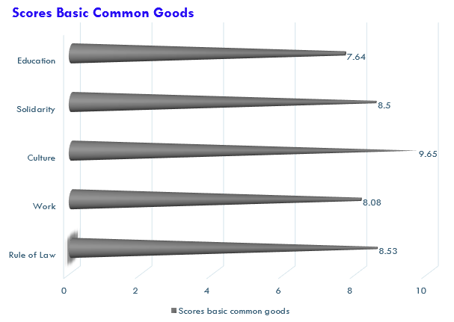
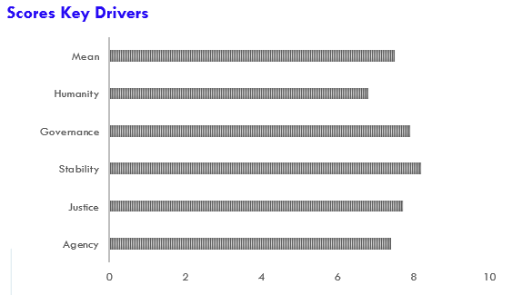

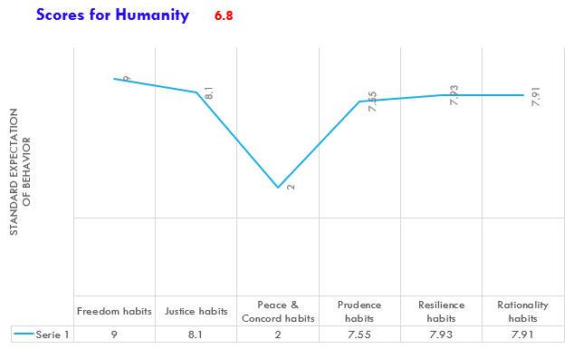

  - At the systemic level
A first observation is that while the aggregated Common Good Dynamic (CGD) for Ocotepec is that of 2.5, this still qualifies for a reading between ‘Vulnerable positive social dynamic’ and ‘In transition positive social dynamic’. The situation is therefore frail, suggesting several vulnerability spots. One of these immediately strike out, with the low score of Humanity (1.8), which in turn seems mostly driven by the negative reading of ‘Peace and Concord’ (-3: Vulnerable negative social dynamics). This is not surprising, since violence, impunity and criminality are rife in the region. What is interesting; however, is that the reading refers to a ‘standard expectation of behaviour’, meaning that people have internalized violence as a new social norm and behave accordingly. This is in sharp contrast with the 2.5 reading for ‘rule of law’. It seems that the Rule of law can coexist with a lack of peace and concord in Ocotepec. This paradoxical result is in itself interesting and points at the complexity of the endemic social violence in Mexican communities.
A second piece of information immediately accessible at the systemic level is that the three instrumental key drivers of justice (2.7), stability (2.9) and governance (3.2) are substantially lower than the scores obtained for the ‘Basic Common Goods’ (to the exception of Rule of law 2.5). Since each of these three key drivers’ indicators is partly built on the distribution, governance and stability of the basic common goods, we must conclude that the lower readings refers to the way they are coordinated to each other (which make up the other part of each key driver indicators). In plain English, the systemic integration of each of these key drivers is problematic and affects the overall CGD. Rather than the procurement of basic common goods, it seems that the difficulty is to reach them together. To merely focus on each basic common good may thus actually hide the fact that their procurement does not build up a positive system (virtuous circle). Moreover, the gap between the scores of Humanity (mean 1.8) and those of Basic Common Goods (mean 3.45) clearly shows that a good result on basic features of development does not automatically translate into a higher score of the way people behave in a society. Again, this gap points to the complexity of development processes and to the unresolved question of the behavioural changes needed to reach sustainable development.
  - At the Level of Each Key Drivers of CGD
Another piece of valuable information provided by the metric is identifying within each key driver some of the weakest features of this dimension. It may help pinpoint very specific problems that hinder this dimension. Indeed, as we think here of a development process, one or several bottlenecks may have a disproportionated effect on the whole dimension. The following case, taken again from our pilot probe, illustrates this point.
Figure 4. Agency Scores for Ocotepec
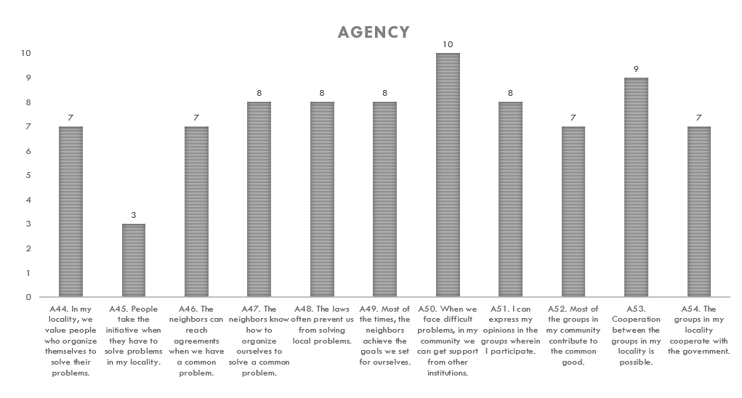While 10 of the 11 indicators are in positive territory, one clearly strikes out as negative, bearing down on the rest of the dimension (geometric means). It is interesting to see that the local bureaucracy is identified as a major hurdle impeding the expression of ‘Collective Agency Freedom’. While not conclusive, as our data for the pilot probe is not strong enough, such disaggregated information may help identify the weakest element of development processes and strategically target interventions or development policies.
Another use for the information given by the metric, is to identify eventual cluster of social groups (cluster by age, sex, profession, socio-economic position, geography) that are in the position to tip over the social dynamic. The limits of the pilot probe did not allow for it, but potentially this may be the most relevant information provided by the metric. It may help design interventions or policies that pre-empt the sudden tipping over of an existing positive social dynamic towards a negative one. This information is of crucial importance so as to appraise the time and effort needed to reach development goals. ‘Dominant negative social processes’ will be hard to dismantle and reverse while ‘Vulnerable positive social processes may require much less efforts to be stabilized. In other terms, the metric offers, to decision makers and development planners, critical strategic information about the timing, cost and chances of success of an intervention.
It is this hability to think both systemically and strategically about development processes that distinguishes our approach. It is its strength and arguably also its weakness. None of this data should therefore be taken alone, but enriched and contrasted with other development indicators.

  - Bibliography
Bourdieu, P. (1977), Outline of a Theory of Practice. Cambridge: CUP.
Bourdieu, P., (1990). The logic of practice, Stanford: Standford University Press.
Centola D., (2018), How behaviors spreads. The science of complex contagions. Princeton: Princeton University Press.
Centola D., Becker J., Brackbill D., Baronchelli A. (2018), "Experimental evidence for tipping points in social convention", Science 360/6393, 1116-1119.
De Angelis, M. & Harvie, D. (2013). “The Commons”. In Parker M., Cheney G., Fournier V., Land C. (Eds.), The Routledge Companion to Alternative Organization, London: Routledge, 280-294.
Euler, J. (2018), “Conceptualizing the Commons”, in Ecological Economics 143, 10-16.
EVS (2015), European Values Study Longitudinal Data File 1981-2015 (EVS 1981-2015). GESIS Data Archive, Cologne.
Giddens, A. (1986), The constitution of society. Outline of the theory of structuration. Oxford: Blackwell, 5-28.
Granovetter, M. (1978), “The strenght of weack ties: a network theory revised”, in American Journal of Sociology 83/6, 1420-1443.
Granovetter, M. (1983), “Threshold models of collective behavior”, in Sociological Theory 1/1, 201-233.
Hibst P. (1991), Utilitas Publica – Gemeiner Nutz – Gemeinwohl. Frankfurt: Peter Lang.
Ibrahim S.I. (2016), “How to Build Collective Capabilities: The 3C-Model for Grassroots-Led Development” in Journal of Human Development 18/2 (2017), 197-222.
Kaul I., Grunberg I., Stern M.A., Eds (1999), Global Public Goods. Oxford: OUP/PNUD Press.
Kempshall M. (1999), The common good in late medieval political thought. Oxford: Oxford University Press.
Lecuppre-Desjardin E. & Van Bruaene A.L., Eds (2010), The Discourse and Practice of the Common Good in the European City. Turnhout: Brepols.
Marwell G., Oliver P. (1993), The Critical Mass in Collective Action. Cambridge: Cambridge University Press.
Nebel, M. (2018a) "Searching for the common good", In Nebel & Collaud (Eds), Searching for the common good, Baden-Baden: Nomos Verlag, 111-148.
Nebel M. (2018b)"Operacionalizar el bien común. Teoría, vocabulario y medición", in Metafisica y Persona 10/20, 28-66.
Ostrom E. (1990), Governing the Commons, Cambridge, CUP.
Putnam D. (2000), Bowling Alone: The Collapse and Revival of American Community. New York: Simon & Schuster.
Ricœur, P. (2001), « De la morale à l’éthique et aux éthiques », in Le juste II, Paris : Esprit, 55-67.
Rigaudière, A. (2010) "Donner pour le bien commun et contribuer pour les biens communs dans les villes du midi français du XIII au XV siècle", In Lecuppre-Desjardin & Van Bruaene, De Bono Communi, 11-53.
Sassier Z. (2010) “Bien commun et utilitas communis au XIIe siècle, un nouvel essor? ”, in Revue Française d'Histoire des Idées Politiques 32/2, 245-258.
Spaiser V., Hedstrom P., Ranganathan S., Jansson K., Nordvik M., Sumpter D. (2018), "Identifying Complex Dynamics in Social Systems: A New Methodological Approach Applied to Study School Segregation", in Methods & Research Vol. 47/2, 103-135.
Ulrike D. (2013), “The Rise of the “Global Social” Origins and Transformations of Social Rights under UN Human Rights Law”, International Journal of Social Quality 3/2, 41-59.
Van Laerhoven, F. & Berge, E. (2011). “The 20th anniversary of Elinor Ostrom’s Governing the Commons”. International Journal of the Commons, 5/1, 1-8
Wiedermann, M., Smith, E.K., Heitzig, J. (2020), “A Network-Based microfoundation of Granovetter’s threshold model for social tipping” in Scientific Report 10/11202.
Zamagni S. (2018), "The common good and the civil economy", In Nebel & Collaud (Eds), Searching for the common good, Baden-Baden, Nomos Verlag, 2018, 79-98.
Zamagni S., Bruni L. (2007), Civil economy: efficiency, equity, public happiness. Bern: Peter Lang.

Appendix 1. Description of the solution space.
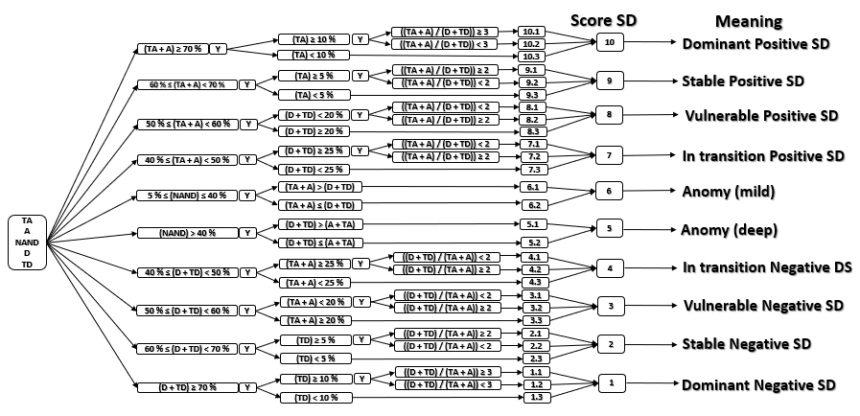

Mathias Nebel is a full-time professor of Social Ethics and Christian Social Thought at the Universidad Popular Autónoma del Estado de Puebla. He is the director of the research institute Instituto Promotor del Bien Común.
Ignacio Arbesu is a full-time professor of Politology at the Universidad Popular Autónoma del Estado de Puebla.
CONEVAL has a multidimensional approach to poverty, using ‘income’, ‘educational lag’, ‘lack of access to health services’, ‘lack of access to social security’, ‘inadequate housing’, ‘lack of access to food’ and ‘degree of social cohesion’ as indicators to identify poverty. For an individual to be considered poor, one or more of these social deprivations must be present.
Basically, goods you can’t reduce to a sum/aggregation of individual goods. Charles Taylor, Philosophical arguments, Cambridge, Harvard University Press, 1995, Chap. 7: Irreducibly Social Goods.
Two large set of studies empirically ground the matrix. The first is related to the work done by Ostrom and the International Association for the Study of the Commons (IASC). The second are the so-called Community Based or Driven Development Programs (CBD & CDD). The experience gained from both set of empirical studies served to create our matrix of common good dynamics.
The list is loosely inspired by the International Covenant on Economic, Social and Cultural Rights (ICESCR, 1976). Collective rights may indeed be understood as protecting common goods.
As a basic common good culture must consider: a. The community that values and defines it as a common good; b. The formal and informal interactions by which the common memory and traditions, language and values are inhabited by a given population; c. The common benefit created by these interactions
As a basic common good, education must consider: a) The community that values and defines it as a common good; b) The formal and informal interactions trough which education is conveyed from one generation to the other; c) The common benefit created by these interactions and how it must be used and shared.
As a basic common good solidarity must consider: a. The community that values and defines it as a common good; b. The formal and informal interactions safeguarding each other in times of need or distress in a society; c. The common benefit created by these interactions, the legitimate use of solidarity and its distribution among the population.
As a basic common good work must consider: a. The community that values and defines it as a common good; b. The formal and informal interactions by which work is socialized; c. The common benefit created by these interactions, the legitimate use of work and its distribution among the population.
As a basic common good rule of law must consider: a. The community that values and defines it as a common good; b. The formal and informal interactions by which a fair recognition of our common dignity and freedoms is enacted in a population, more specifically how a set of basic rights and freedoms is guaranteed, upheld and enforced by the state; c. The common benefit created by these interactions.
Municipalities conform the third and lower level of state governance in Mexico. While Mexico is a Federal State and nominally recognizes decentralization as one of the State’s core principles, it is in fact highly centralized. Therefore, while the constitution recognizes many specific obligations to municipalities taxes are collected at the federal level and only distributed to municipalities according to the priorities of the federal state. Without access to proper funding, many local initiatives can’t be developed.
Beyond existence, the crucial questions are: How are they structured in the nexus? Which ones are considered the most basic? Which are considered important? Which ones are considered at odd with others? How many are problematic? Which ones come on top as a practical priority in the present context? The point is to see if they build coherently in the nexus or not.
We use here the word in the specific sense given to it by Bourdieu: "The conditionings associated with a particular class of conditions of existence produce habitus, systems of durable, transposable dispositions, structured structures predisposed to function as structuring structures, that is, as principles which generate and organize practices and representations that can be objectively adapted to their outcomes without presupposing a conscious aiming at ends or an express mastery of the operations necessary in order to attain them" Bourdieu, P., (1990). The logic of practice, Stanford: Stanford University Press, 53.
for a much more detailed presentation of the instrument see this issue of Garza Vázquez & Ramirez.
An alternatives method to gauge exogenous thresholds could be Bayesian equations systems. Other methods have also be considered but not applied.
Our approach is normative. We therefore set that some social dynamics add to a common good dynamic whereas their absence or an altogether opposite SD will disrupt the emergence of a common good dynamics. Mind however that in our understanding the list of habitus and basic common goods are open ones that should be discussed and decided by local communities. But as a metric and for the sake of comparison, we needed to settle for a specific set of habitus and basic common goods.
‘Negative’ describes here a social dynamic opposed to the positive one. It is not characterized in itself, but only by this opposition. Such ‘unity of opposition’ may well actually suppose a diversity of practices. There may be different types of oppositions and not necessarily articulated between them, like opposition parties against a ruling party. However, as far as we are concerned, regarding the stability of social dynamic, what matters is the size of the opposition and the size of the ‘undecided’ people, as argued in the previous point. As such, all forms of oppositions may be counted as one.
Due to some limitations in the sample, the results of the pilot probe are not robust enough to qualify for statistic validity. Nonetheless, we can use them to give examples of what sort of information may be gathered from the metric and which added value it may have for development policies. The common good dynamics’ instrument (the questionnaire) used for this pilot probe was version 14, amended to version 19, which is the one described previously in this article.
Ocotepec is a small, rural municipality of the state of Puebla with a total population of about 4,779 people (2015). The municipality spans over a landscape of steep hills and is mainly dedicated to subsistence agriculture. It is overwhelmingly poor (76% of the population) with 16% living in extreme poverty and a further 20% being vulnerable. Only 2% of the population is said to be not poor and not vulnerable (CONEVAL 2015). A central village called Ocotepec gives the municipality its mane. In the hills are several ‘communities’ most of them bilingual (Nahuatl/Spanish) poorly connected by dust roads. The municipality has a long history, at least dating back to the Conquista, and was most probably built on the previous indigenous village. We administered 280 questionnaires in July 2019, with the help of the local government.

